**Database Project Report**

**Group: N.W.A**

Hamza Rizvi Syed.M.Nayl Shehreyar Abidi

**Introduction:**

A system for our Operator to overlook the entries or make the entries made at the entrance gate of the university campus for Vehicles.

**Entries**:

* Student Entry: A student is checked in for time in and time out. If he’s not registered, they are taken to a form to register for the entry!
* Faculty Entry: When a faculty arrives, they are taken to the check in and time in/out. If their vehicle isn’t registered in the database, their customized registration form is opened for them to register their vehicle.
* Guest Entry: A guest must provide their latest details with CNIC and other information. \
* Staff Entry: A staff member will be checked into the campus if their vehicle is registered. If not, they have to register their vehicle in the new form opened for them.

**Forms:**

* Login Screen: The login screen is the first window we see and is so that the operator logs in.
* Welcome Screen: Form presents to the viewer four options depending whether its student, faculty, staff or a guest.
* Student Form: Makes you enter time in and time out of the student. Register them if they are not registered.
  + View form opens the Student Info form which gives the details about that student.
  + Register form opens the Register Student form where we can register them.
* Faculty Form: Makes you enter time in and time out of the faculty member. Register them if they are not registered.
  + View form opens the Faculty Info form which gives the details about that Faculty member on campus.
  + Register form opens the Register Faculty form where we can register them.
* Staff Form: Makes you enter time in and time out of the staff. Register them if they are not registered.

* + View form opens the staff Info form which gives the details about that staff.
  + Register form opens the Register Staff form where we can register them.
* Guest Form: Makes you enter time in and time out of the Guest. Register them if they are not registered.

* + View form opens the staff Info form which gives the details about that Guest.
  + Register form opens the Register Guest form where we can register them.

**Screenshots:**

Login:

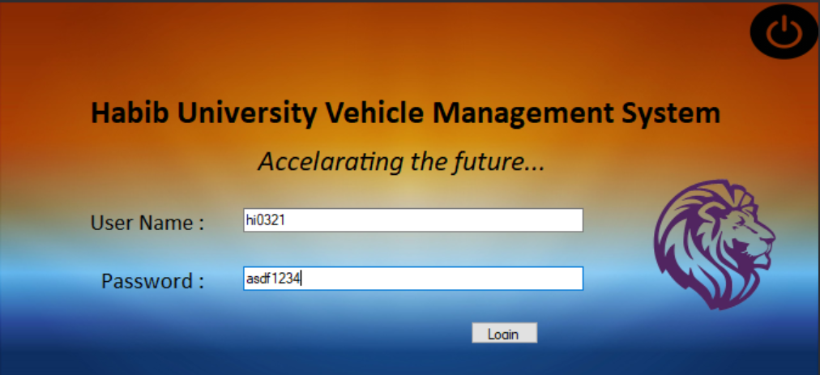

A simple login screen

After login:

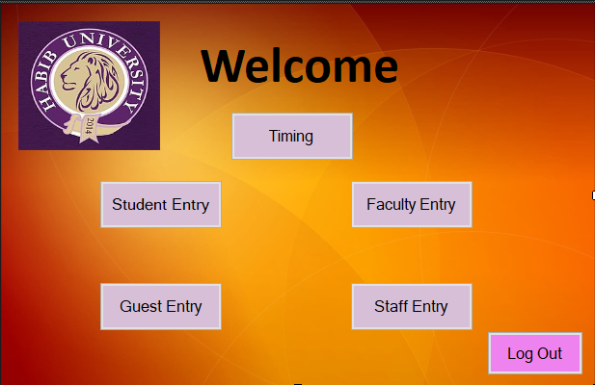

Five buttons, each of student, faculty, guest and staff entry then have two options of simply viewing person data or registering a new person

The timing button is to enter the time in and time out of the already registered people

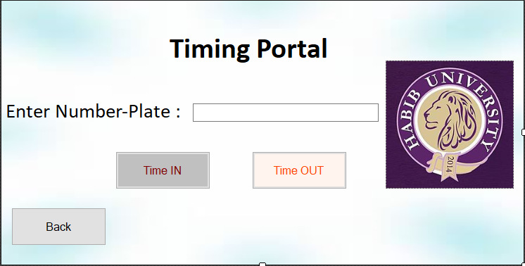

Transition Forms:

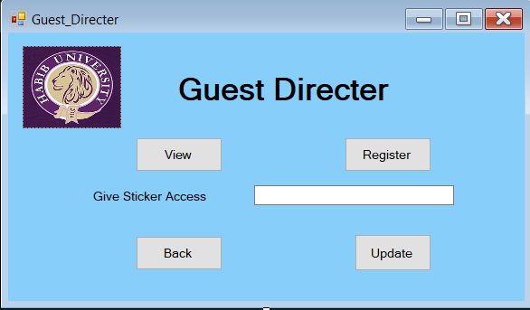

Using Give sticker access, we can give a certain number plate access to the parking

View shows the related info of the searched car, register allows you to sign up a new car into the system

View From: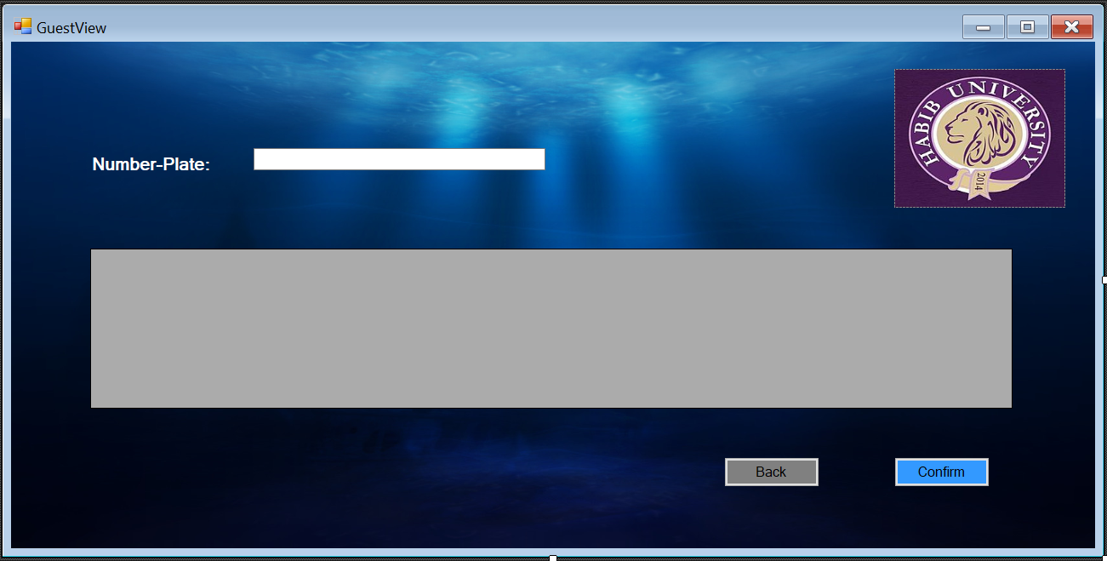

Searches for the number plate and displays the relevant info in a gird view. The form has the same format for all four type of people

Register Forms:

